VLSI GURU
AI LITERACY LAYER-WEEK 01
STUDENT ASSESSMENT
Topic: Artificial Intelligence and Its Applications in VLSI
Submitted by:Jeevana Sravanthi Dusanapudi

Mission 1 — Find AI Around You
S. No. | AI System/Feature | What I Think It Does | Evidence of AI/ML
1 | YouTube Recommendations | Recommends videos based on my interests and watch history. | YouTube uses machine learning to recommend videos to users.
2 | Google Maps | Predicts traffic and suggests the best route to reach a destination. | Google Maps uses machine learning and other technologies to predict traffic and travel times.
3 | Google Assistant | Recognises my voice and responds to my questions. | Google Assistant uses speech recognition and AI technologies to understand voice commands.
Rule-Based Program Example
Google Maps can also use a simple rule-based program to find a route. For example, a program could be designed to select the shortest route from one place to another. However, predicting traffic conditions requires more information and may involve machine learning.
Conclusion
AI is a part of my daily life. I use AI-powered features such as YouTube recommendations, Google Maps, and Google Assistant. These technologies help me find information, travel easily, and save time. I learned that AI can recognise, predict, and recommend things based on data.
Mission 2 — AI, ML, GenAI: Put the Pieces Together
1. Explain AI, ML, Deep Learning, and Generative AI
1. Artificial Intelligence (AI):
AI is a technology that enables computers to perform tasks that normally require human intelligence, such as solving problems, recognising speech, and making decisions.
Example: Google Assistant.
2. Machine Learning (ML):
ML is a part of AI that allows computers to learn patterns from data and make predictions or decisions without being explicitly programmed for every situation.
Example: YouTube recommending videos based on our interests.
3. Deep Learning (DL):
Deep Learning is a part of machine learning that uses multi-layered neural networks to learn complex patterns from large amounts of data.
Example: Face recognition on smartphones.
4. Generative AI (GenAI):
Generative AI is a type of AI that can create new content, such as text, images, music, and code, based on the patterns it has learned.
Example: ChatGPT generating answers to questions.
2. Diagram Showing the Relationship Between AI, ML, Deep Learning, and Generative AI
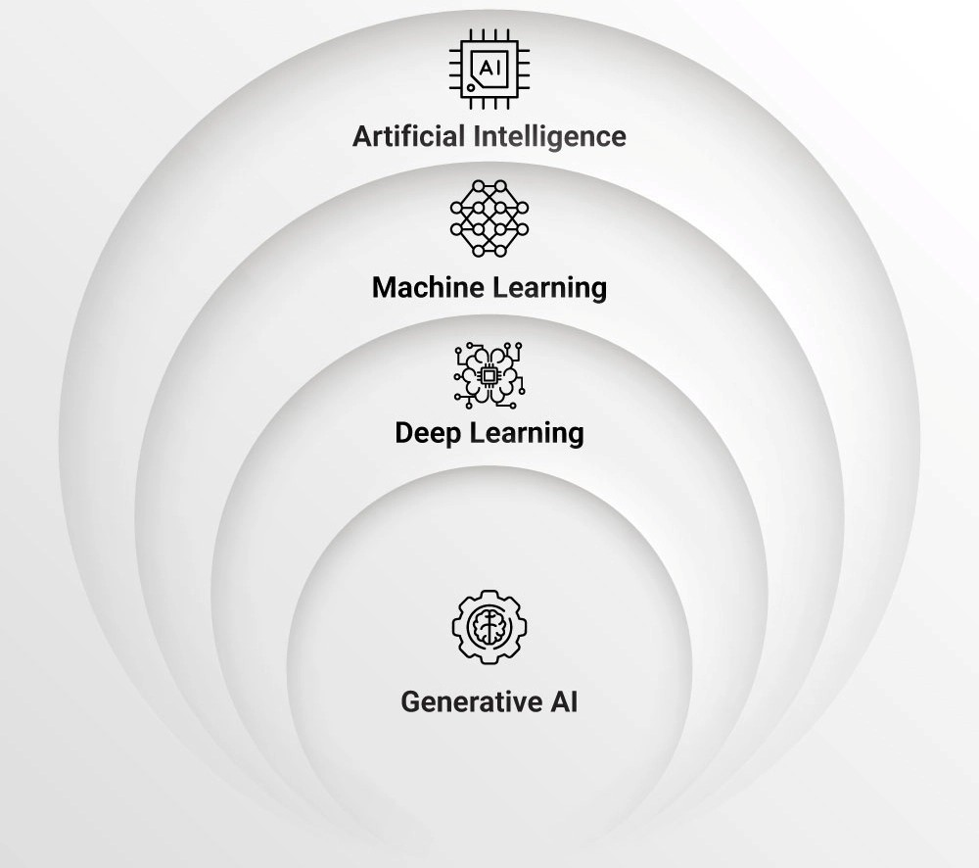

Note: This diagram is a simplified representation. AI includes ML, and ML includes deep learning. Generative AI overlaps with deep learning, but not all generative AI is necessarily deep learning, and not all deep learning is generative AI.
3. How I Checked My Diagram Using an AI Assistant
I asked an AI assistant to explain the relationship between AI, ML, deep learning, and generative AI. It explained that AI is the broadest field, ML is a part of AI, and deep learning is a part of ML. Generative AI focuses on creating new content and often uses deep learning.
I corrected my understanding to show that generative AI is not always a subset of deep learning; it can also use other approaches.
4. Conclusion
AI helps computers perform intelligent tasks. Machine learning helps computers learn from data, while deep learning learns complex patterns using neural networks. Generative AI creates new content such as text, images, and code. These technologies are related, but each has a different purpose.

Mission 3 — Is It Really AI?
1. Classification Table
S. No. | System | Classification | Reason
1 | Calculator | Rule-based/Traditional Software | It performs calculations using predefined mathematical rules.
2 | Temperature Warning Rule | Rule-based/Traditional Software | It gives a warning when the temperature crosses a fixed limit.
3 | Spam Filter | ML-based AI | It learns patterns from emails to identify spam messages.
4 | Document Summariser | Generative AI | It generates a shorter version of a document using AI.
5 | Traffic ETA Prediction | ML-based AI | It uses traffic data and patterns to predict travel time.

2. One Easy Classification
Calculator — Rule-based/Traditional Software
This classification was easy because a calculator follows predefined mathematical rules to perform calculations. It does not need to learn from data.
3. One Difficult Classification
Spam Filter — ML-based AI
This classification was difficult because some spam filters use fixed rules, while others use machine learning to identify spam based on patterns in emails. Therefore, the classification depends on how the spam filter is designed.
4. My Own Example
Example: Face Recognition on a Smartphone
Classification: ML-based AI.
A smartphone can use machine learning to recognise a person's face and unlock the device. It learns facial patterns during the setup process and compares them when someone tries to unlock the phone.
Conclusion
Traditional software follows explicitly programmed rules, while machine learning learns patterns from data. Generative AI creates new content, such as text and summaries. Therefore, not every system that behaves intelligently is necessarily AI.
Mission 4 — Make AI Explain Itself, Then Test It
1. How Does an LLM Produce an Answer to My Prompt?
A Large Language Model (LLM) is an AI system trained on large amounts of text. When we enter a prompt, the model processes the text and predicts the next token based on the context. It continues generating tokens one by one until it produces an answer. During training, it learns patterns in language that help it answer questions, summarise information, and generate text.
2. Beginner Explanation With a Simple Example
Imagine I ask an AI assistant, "The sun rises in the ____."
The AI predicts a suitable next word, such as "east." Similarly, when I ask ChatGPT a question, it processes my words and generates a response one piece at a time.
For example:
My prompt: What is AI?
AI response: AI is a technology that helps computers perform tasks that normally require human intelligence.
The AI uses patterns learned during training to generate a relevant answer.
3. My Final Explanation
An LLM produces answers by processing the prompt we provide. First, it converts the text into small units called tokens. Next, it uses a trained neural network to understand the context and predict suitable next tokens. It generates these tokens one by one until the answer is complete.
An LLM can produce useful answers, but it can also make mistakes or generate incorrect information. Therefore, we should verify important information using reliable sources.
4. Evidence From Reliable Sources
Source 1: OpenAI
OpenAI explains that language models learn patterns from large amounts of text and generate responses by predicting what comes next.
Read more: How ChatGPT and Our Language Models Are Developed
Source 2: Stanford University
Stanford explains that large language models are trained on large amounts of text and use deep learning to generate human-like language.
Read more: What Is a Large Language Model? — Stanford HAI

Two Important Claims I Verified
- Claim: LLMs process text in tokens.
Verification: OpenAI confirms that text is divided into tokens before being processed by the model.
- Claim: LLMs predict the next token to generate text.
Verification: OpenAI and Stanford's explanations support the idea that language models learn patterns and generate text through prediction.
5. What the AI Explained Well
The AI explained clearly that an LLM generates an answer step by step by predicting the next token. The simple sentence example helped me understand this process.
6. What I Had to Clarify or Correct
At first, I thought an LLM searches for an exact answer in its training data. I clarified that it generally generates new text using patterns learned during training rather than simply copying a stored answer. Some AI systems can also use search tools or other external information sources.
Conclusion
I learned that an LLM processes a prompt and generates a response one token at a time. Although AI can explain many topics, its answers are not always correct. Checking important claims using reliable sources helps us understand AI more accurately.

Mission 5 — Can AI Be Confidently Wrong?
1. Prompt
I asked an AI assistant: "Does a heavier object fall faster than a lighter object?"
2. AI Answer
In the absence of air resistance, heavier and lighter objects fall at the same acceleration due to gravity. However, in the presence of air resistance, they may fall at different speeds depending on their shape, size, and mass.
3. Verification Source
Source: NASA — National Aeronautics and Space Administration.
NASA explains that objects fall at the same rate in a vacuum, where there is no air resistance.
Source link: https://www.nasa.gov/
4. Result
Classification: Correct, with clarification.
The AI's answer was correct because objects experience the same gravitational acceleration in a vacuum. However, air resistance can affect how quickly objects fall through the atmosphere. My verification supports the main scientific claim, but it does not prove that every detail of the AI's answer is correct.
5. Lesson Learned
I learned that an AI answer can sound confident but still needs verification. Checking reliable sources helps us identify correct information and understand important conditions or exceptions. We should verify facts before trusting or sharing them.

Mission 6 — Chatbot or Agent?
1. Explanation of Important Terms
1. LLM (Large Language Model):
An LLM is an AI model trained on large amounts of text to understand prompts and generate human-like responses.
Example: GPT.
2. AI Application:
An AI application is a software program that uses AI to perform a particular task.
Example: A chatbot that answers customer questions.
3. RAG (Retrieval-Augmented Generation):
RAG is a technique in which an AI system retrieves relevant information from external documents or databases and uses it to generate an answer.
Example: A chatbot that answers questions using a college handbook.
4. Tool-Using Assistant:
A tool-using assistant is an AI system that can use external tools to perform tasks or obtain information.
Example: An AI assistant that uses a calculator to solve a mathematical problem.
5. Agent:
An AI agent is a system that can work toward a goal by deciding what steps to take, using tools, observing results, and taking further steps when needed.
Example: An AI assistant that plans a trip, checks transport options, and prepares an itinerary.
2. Simple Flow Diagram
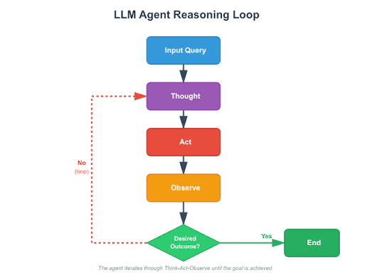
Note: An agent may repeat the tool-use and result-checking steps until it completes its goal or needs further input from the user.
3. Comparison Table
System | Meaning | Main Function | Example
LLM | A language model trained on text | Generates and understands text | GPT
AI Application | Software that uses AI | Performs a specific task | Customer support chatbot
RAG | Retrieves information before generating an answer | Provides answers using relevant external information | College document chatbot
Tool-Using Assistant | AI that can use external tools | Performs tasks using tools | AI using a calculator
Agent | AI system that works toward a goal through multiple steps | Plans, uses tools, and adjusts its actions | AI travel-planning assistant
4. Everyday Example of an Agentic Workflow
Example: Planning a Trip
Suppose I want to travel from Hyderabad to Bengaluru.
- I tell the AI assistant my destination, budget, and travel date.
- The assistant identifies the information it needs.
- It checks available trains or buses using suitable tools.
- It compares travel times and prices.
- It prepares a travel plan based on my preferences.
- It presents the plan for me to review.
If booking is required, the assistant should ask for my confirmation before making a purchase.
This is an example of an agentic workflow because the system works toward a goal through multiple steps and uses tools to obtain information.
Conclusion
A chatbot mainly answers questions, while a tool-using assistant can also retrieve information and perform tasks. An AI agent can go further by planning and taking multiple steps toward a goal. These systems can make AI more useful in everyday life.

Mission 7 — What Actually Runs AI?
1. What Is a CPU and What Is It Good At?
CPU (Central Processing Unit) is the main processor of a computer. It executes instructions, performs calculations, and controls different operations. It is good at handling general-purpose tasks and sequential operations.
Example: Running applications, browsing the internet, and managing the operating system.
2. What Is a GPU and Why Is It Useful for AI Workloads?
GPU (Graphics Processing Unit) is a processor designed to perform many calculations in parallel. AI models require large numbers of mathematical operations, so GPUs can process many of them simultaneously.
Example: Training deep learning models and generating AI images.
3. What Is an NPU / AI Accelerator and Why Do Modern Systems Use Specialised Hardware?
NPU (Neural Processing Unit) is a specialised processor designed to accelerate AI operations, especially neural network computations. An AI accelerator is hardware designed to perform AI tasks efficiently.
Modern systems use specialised hardware to improve performance, reduce power consumption, and speed up AI computations.
Example: An NPU in a smartphone can accelerate certain AI features while using less power.
4. What Does Parallel Computation Mean?
Parallel computation means performing multiple calculations at the same time instead of completing every calculation one after another.
Example: A GPU can perform many mathematical operations simultaneously when processing an AI model.
5. Why Does AI Depend So Heavily on Compute and Memory?
AI depends on compute because models perform many mathematical calculations. It depends on memory because models need to store their parameters, input data, and intermediate results.
Sufficient computing power and memory help AI models run faster and process larger amounts of data.
6. What Is the Difference Between Training and Inference?
Training | Inference
The model learns patterns from training data. | The trained model produces predictions or answers.
Model parameters are updated during training. | Model parameters usually remain unchanged.
Requires many calculations and often substantial computing resources. | Computing requirements depend on the model size and the task.
GPUs or specialised accelerators are commonly used. | CPUs, GPUs, or specialised accelerators can be used.
Example: Training a chatbot model. | Example: Asking a trained chatbot a question.
- Simple Diagram: What Actually Runs AI?



Explanation: The AI application uses an AI model through software or a framework. The software executes computations on hardware such as a CPU, GPU, or AI accelerator. Memory stores the model parameters, data, and intermediate results needed during execution.
Note: Memory works alongside the processors and is connected to them; it is not simply a stage that comes after the hardware.
8. One Real AI Workload Example
Example: AI Image Generation
When I enter a prompt into an AI image generator, the AI model processes the prompt and performs many mathematical calculations to generate an image.
A GPU is useful for this workload because it can perform many calculations in parallel. High-bandwidth memory helps supply the model with data efficiently. For large models, sufficient memory capacity is also important.
A CPU can manage application tasks, while a GPU or specialised accelerator performs much of the intensive AI computation.
Conclusion
AI is software that runs on computing hardware. CPUs handle general-purpose tasks, GPUs accelerate parallel calculations, and NPUs are designed to perform AI operations efficiently. Memory stores the model and data required for computation. The combination of hardware, computation, and memory determines the speed and efficiency of AI systems.

Mission 8 — Where Could AI Help Your VLSI Track?
Selected Area: Physical Design (PD)
Item | Answer
VLSI Area | Physical Design (PD)
Task | Placement and Routing Optimization
How AI Might Help | AI can analyse design data and help optimise the placement of cells and routing to improve timing and reduce congestion.
Why Human Knowledge Matters | A physical design engineer must verify the results and ensure that the design meets timing, power, and area requirements.

Conclusion
AI can help physical design engineers analyse data, optimise designs, and reduce repetitive work. However, human expertise is essential to verify the results and ensure that the chip meets all design requirements.

Mission 9 — Build Your Own AI-Use Rule
My 5-Rule AI Working Agreement
Rule 1: Verify Information
I will verify important AI-generated answers using reliable sources, textbooks, or official documentation before accepting them as correct.
Rule 2: Protect Confidential Information
I will never share confidential company data, chip designs, source code, passwords, or proprietary information with public AI tools without proper authorisation.
Rule 3: Take Responsibility for My Work
I will understand, check, and correct AI-generated answers before using them in my assignments or engineering work. I will take responsibility for my final work.
Rule 4: Use AI to Learn, Not Just Copy
I will use AI to understand difficult VLSI concepts, clarify doubts, and explore examples instead of blindly copying its answers.
Rule 5: Check AI Answers for Errors
I will not assume that an answer is correct just because it sounds confident. I will compare important technical claims with reliable sources and correct any mistakes.
Justification From Missions 4 and 5
In Mission 4, I learned that a Large Language Model generates answers by predicting tokens based on context. In Mission 5, I learned that even a confident AI answer needs verification. Therefore, I will always check important technical information before trusting or using it.
Conclusion
I will use AI as a learning assistant, not as a replacement for my own understanding. I will verify information, protect confidential data, and take responsibility for my final engineering work.

